

Prepared by:

**Gerber Technology**

**YuniquePLM**

**Flash Edit**

The Flash Edit folder is an area where updates can be made to multiple style quotes at one time or multiple material colors at one time. To access Flash Edit Folder, click on the icon with the same name.

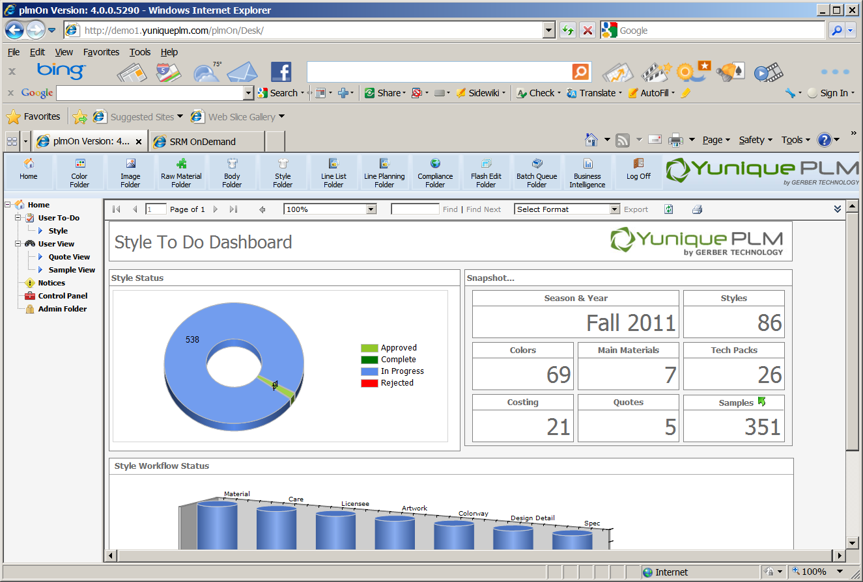

The Flash Edit folder is organized by Style and Material on the left navigation.

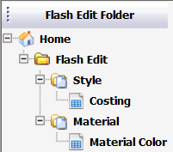

**Style**

The style folder allows for costing information that affects outstanding quotes to be changed for multiple styles at one time.

Clicking directly on the Costing node on the left navigation will display a list of all styles that have outstanding quotes on the right side of the explorer window.

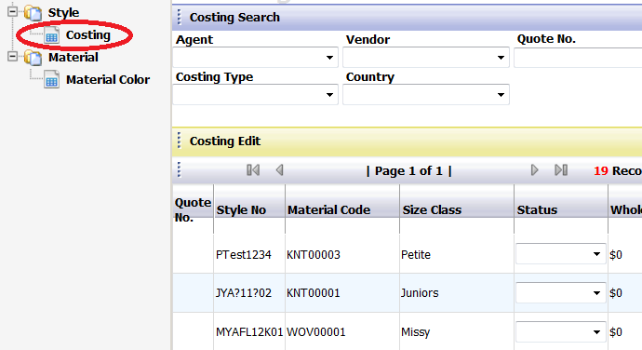

Costing information such as Duty %, Freight, Proposed Units, etc. can be changed for multiple styles at one time. Make any desired changes by clicking in each field and typing or selecting from the drop down list.

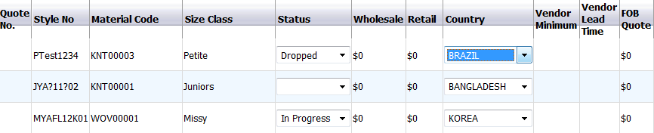

Once all desired data changes have been made click on the save button at the top of the screen. All styles will be updated with the new information provided.



If the same data change needs to be made to multiple styles, such as changing the freight cost for 10 styles, then the Batch Update feature will allow this to be done easily. Place a check mark to the left of the Batch Update header to across the top of the window.

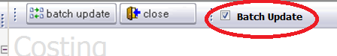

A data entry area will be presented in the center of the screen. Data can be entered in all or selected fields within this area.

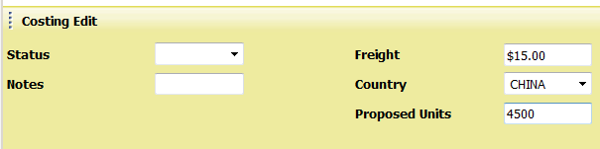

Next, place a check mark in the far left of each style row that will need to receive the updates.

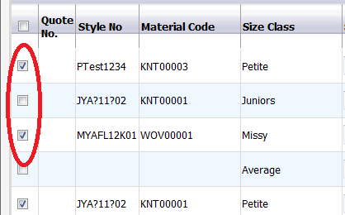

Once the new information has been entered in all desired fields and the styles have been selected, click on the Batch Update button in the upper left corner of the screen to process the changes. The styles will reflect all of the changes made once the update process has been performed.



**Material**

Material colors can be updated in mass by clicking on the Material Color node on the navigation.

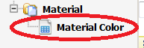

A list of all colorways associated with Raw Materials will be presented on the right side of the explorer window. Information can be entered into the Color Code, Color Name and Sort fields for updates to the material colorways.

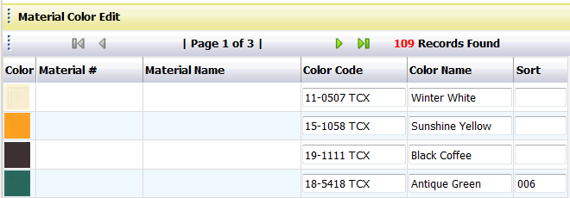

Once all desired data changes have been entered, clicking the Save button in the upper left corner of the screen will update all records with the changes.



If a single change is needed for multiple material colorways, then the Batch Update function can be used to process the change. Place a check mark to the left of Batch Update field across the top of the screen.

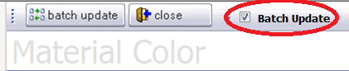

A data entry area will be presented in the center of the screen. Data can be entered in all or selected fields within this area.

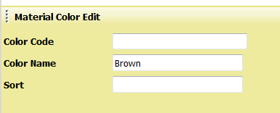

Next place a check mark to the left of each color row to receive the changes.

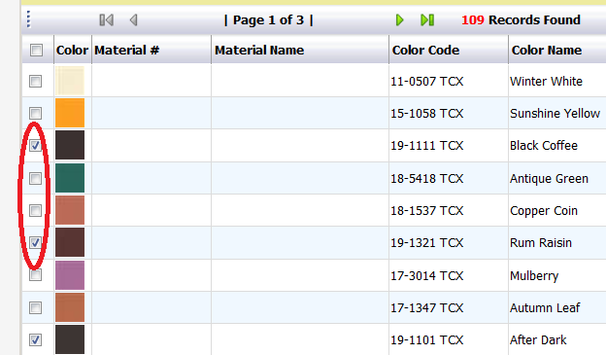

Once the new information has been entered in all desired fields and the colors have been selected, click on the Batch Update button in the upper left corner of the screen to process the changes. The colors will reflect all of the changes made once the update process has been performed.

